SRS Architecture
Universal Assistive Support System
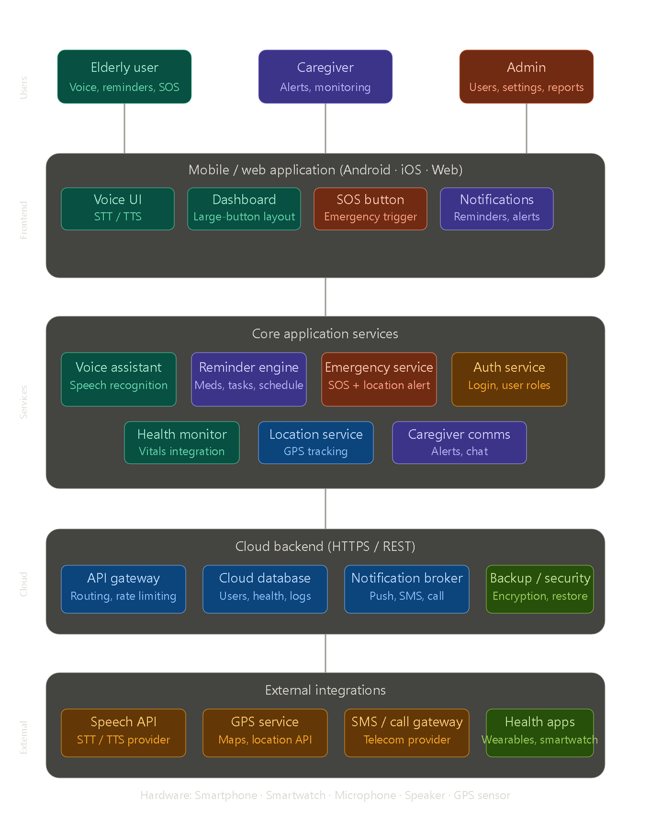
Users — Three actor types: elderly users (primary beneficiaries), caregivers/family (monitoring & alerts), and admins (system management).
Frontend App — The mobile/web application exposes four key UI modules: a voice interface with STT/TTS, a large-button accessible dashboard, the emergency SOS trigger, and a notification/reminder panel.
Core Services — Six backend microservices handle the business logic: voice assistant, reminder engine (medications + tasks), emergency SOS with location, authentication, health monitoring, GPS location tracking, and caregiver communication.
Cloud Backend — API gateway, cloud database (user data, health logs), notification broker (push/SMS/call), and encrypted backup for data security.
External Integrations — Third-party APIs for speech recognition, GPS/maps, SMS/call gateways, and wearable health apps (smartwatches).

